**Bungee Coding Round**

**Problem Statement:-**

You are provided with a file "main.csv" in the input folder. Following operation needs to be provided on the file:-

1. Create an output file "filteredCountry.csv" inside a folder named "output". This file should contain only those records where country contains the word USA.

**Expected output:-**



1. Now consider "filteredCountry.csv" as the input file. For each group of "SKU" find 2 minimum prices and store this result in "lowestPrice.csv" inside a folder named "output"

**Expected output:-**

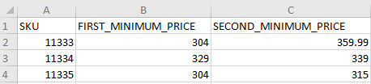

**Submission guidelines:-**

1. You are free to use any coding language.
2. Mention the details that are required to run the code in Github readme file.
3. Fork this repo or create a new Github repo that must contain the following:-
   1. Source code of the solution.
   2. Required output files.
4. Github repo should be public.
5. Link to the Github repo is to be submitted as the answer.